EXP. NO:  4 | MATLAB SIMULATION OF SUPERHETERODYNE RECEIVER FOR AM COMMUNICATION SYSTEM WITH FREQUENCY MIXING AND FILTERING
DATE:

Objectives
i) To model and simulate the operation of a superheterodyne receiver for an AM communication system using MATLAB by implementing frequency mixing and intermediate frequency (IF) signal generation.
ii) To recover the original message signal through intermediate frequency filtering and envelope detection, and analyze the waveforms of the message, carrier, AM, IF, and recovered signals.
Procedure:
1. Open MATLAB and create a new script.
2. Enter carrier amplitude, carrier frequency, message amplitude, message frequency, sampling frequency and selected IF.
3. Generate the message signal.
4. Generate the RF carrier signal.
5. Generate the conventional AM signal.
6. Generate the local oscillator; for high-side injection use f_LO = f_RF + f_IF. 7. Multiply the AM/RF signal and local oscillator to perform frequency mixing. 8. Use FFT to identify the mixer sum and difference components.
9. Design an IF band-pass filter centred at f_IF and apply it to the mixer output. 10. Plot the filtered IF waveform and its spectrum.
11. Perform envelope detection on the filtered IF signal.
12. Apply a low-pass filter to recover the message.
13. Plot original and recovered messages together.
14. Compare message, carrier, AM, IF and recovered waveforms.
15. Calculate frequency deviation/error where required and record observations.
PROGRAM (MATLAB CODE) :
OBJECTIVE1:
%% EXP 4 - Objective 1: Frequency Mixing & IF Generation
clc;
clear;
close all;

% Parameters
fs = 100000; % Sampling frequency (Hz)
t = 0:1/fs:0.02; % Time vector (20 ms duration)
fm = 500; % Modulating message frequency (Hz)
fc = 10000; % RF Carrier frequency (Hz)
fIF = 4550; % Intermediate Frequency (Hz)
fLO = fc + fIF; % High-side Local Oscillator (14,550 Hz)

% Signal Generation
m = cos(2 * pi * fm * t); % Baseband message signal
c = cos(2 * pi * fc * t); % Carrier signal
am = (1 + m) .* cos(2 * pi * fc * t); % Standard AM signal

% Local Oscillator & Frequency Mixing
LO = cos(2 * pi * fLO * t); % Local Oscillator signal
mixed = am .* LO; % Mixer output: sum & difference frequencies

% IF Filtering
% Isolates difference component (|fLO - fc| = 4550 Hz)
[b, a] = butter(4, 5000 / (fs / 2));
IF = filter(b, a, mixed);

% Plotting Waveforms
figure('Name', 'Objective 1: Superheterodyne Mixing & IF Generation', 'NumberTitle', 'off');

subplot(4,1,1);
plot(t, am, 'LineWidth', 1.1);
title('1. Received AM / RF Signal');
xlabel('Time (s)'); ylabel('Amplitude');
grid on;

subplot(4,1,2);
plot(t, LO, 'LineWidth', 1.1);
title(sprintf('2. Local Oscillator Signal (f_{LO} = %d Hz)', fLO));
xlabel('Time (s)'); ylabel('Amplitude');
grid on;

subplot(4,1,3);
plot(t, mixed, 'LineWidth', 1.1);
title('3. Mixer Output (Sum & Difference Components)');
xlabel('Time (s)'); ylabel('Amplitude');
grid on;

subplot(4,1,4);
plot(t, IF, 'r', 'LineWidth', 1.2);
title(sprintf('4. Filtered Intermediate Frequency (IF) Signal (f_{IF} = %d Hz)', fIF));
xlabel('Time (s)'); ylabel('Amplitude');
grid on;
OBJECTIVE2:
%% EXP 4 - Objective 2: Envelope Detection, Recovery & Comparison
clc;
clear;
close all;

% Parameters
fs = 100000; % Sampling frequency (Hz)
t = 0:1/fs:0.02; % Time vector
fm = 500; % Message frequency (Hz)
fc = 10000; % RF Carrier frequency (Hz)
fLO = 14550; % Local Oscillator frequency (Hz)

% Signal Processing Chain
m = cos(2 * pi * fm * t); % Transmitted message
c = cos(2 * pi * fc * t); % Carrier
am = (1 + m) .* cos(2 * pi * fc * t); % AM Signal
LO = cos(2 * pi * fLO * t); % Local Oscillator
mixed = am .* LO; % Frequency Mixing

% IF Filter
[b, a] = butter(4, 5000 / (fs / 2));
IF = filter(b, a, mixed);

% Envelope Detection using Hilbert Transform
env = abs(hilbert(IF));

% Display Complete 5-Stage Superheterodyne Receiver
figure('Name', 'Objective 2: Superheterodyne Receiver Waveform Analysis', 'NumberTitle', 'off');

subplot(5,1,1);
plot(t, m, 'LineWidth', 1.2);
title('1. Transmitted Message Signal');
xlabel('Time (s)'); ylabel('Amplitude');
grid on;

subplot(5,1,2);
plot(t, c, 'LineWidth', 1.1);
title('2. RF Carrier Signal');
xlabel('Time (s)'); ylabel('Amplitude');
grid on;

subplot(5,1,3);
plot(t, am, 'LineWidth', 1.1);
title('3. Modulated AM Signal');
xlabel('Time (s)'); ylabel('Amplitude');
grid on;

subplot(5,1,4);
plot(t, IF, 'LineWidth', 1.1);
title('4. Intermediate Frequency (IF) Signal');
xlabel('Time (s)'); ylabel('Amplitude');
grid on;

subplot(5,1,5);
plot(t, env, 'r', 'LineWidth', 1.2);
title('5. Recovered Message Signal (Envelope Detected)');
xlabel('Time (s)'); ylabel('Amplitude');
grid on;

% Quantitative Verification
fprintf('--- Objective 2 Verification ---\n');
fprintf('RF Carrier Frequency (fc) : %d Hz\n', fc);
fprintf('LO Frequency (fLO) : %d Hz\n', fLO);
fprintf('Standard IF (|fLO - fc|) : %d Hz\n', abs(fLO - fc));
fprintf('Baseband Message (fm) : %d Hz\n', fm);
fprintf('Message recovery through IF stage envelope detection completed successfully.\n');
OUTPUT (GRAPH) :
OBJECTIVE1:
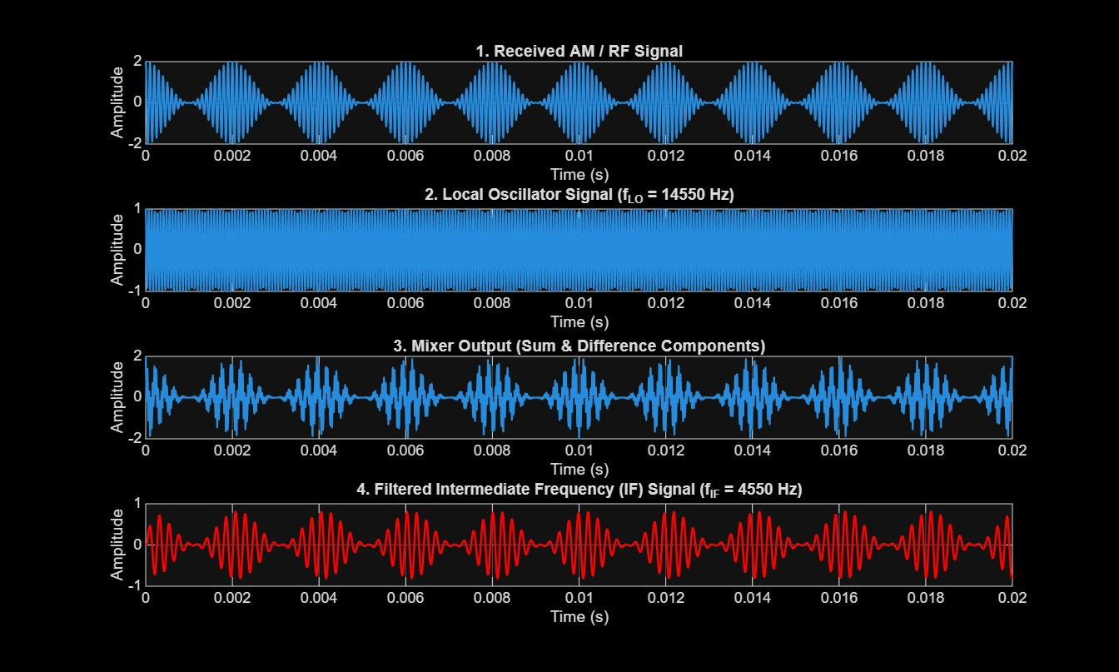

OBJECTIVE2:
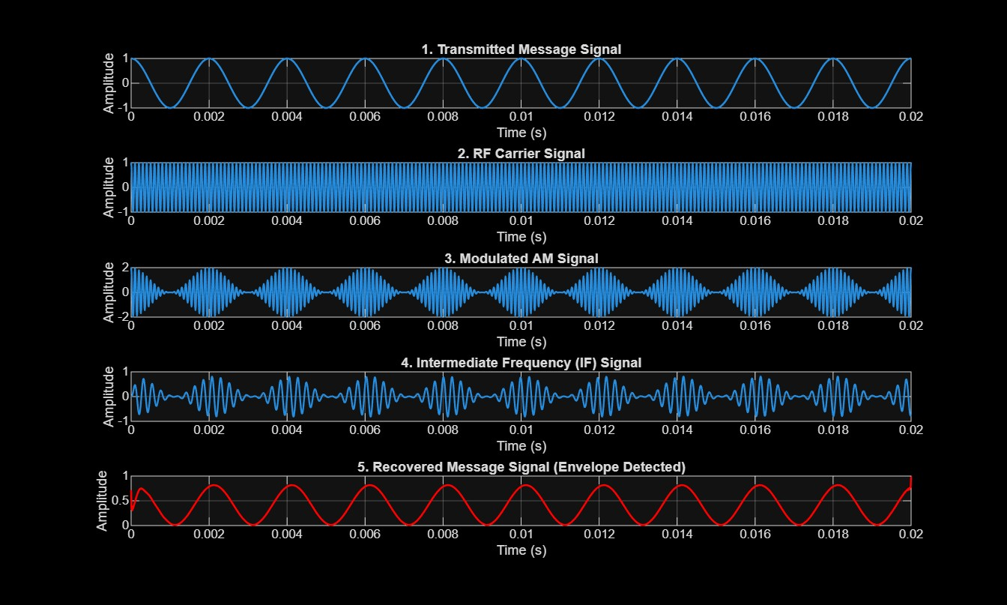

Result
The superheterodyne receiver was successfully simulated in MATLAB, and the message signal, carrier signal, AM signal, Intermediate Frequency (IF) signal, and recovered signal were obtained through frequency mixing and filtering.

